**Practical No. 04**

**Aim: Working with Docker Containers and Commands: Build an image then push it to docker and run it**

Command: to create docker file

1. cat > Dockerfile <<EOF
2. FROM busybox
3. CMD echo "Hello world! This is my first Docker image."
4. EOF

**Output:**

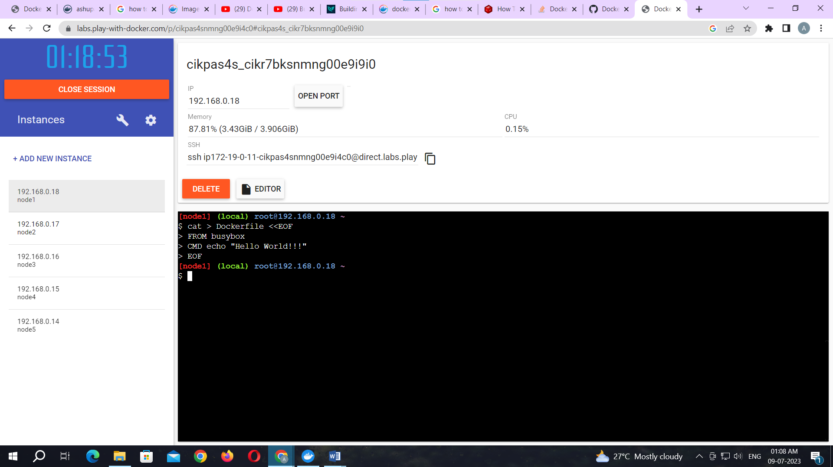

Command: to build image from docker file

docker build -t ashupat/repo6 .

**Output:**

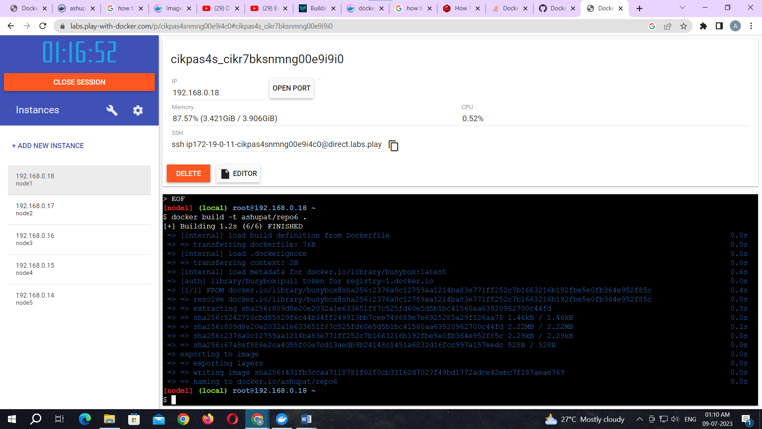

Command: to check docker images

docker images

**Output:**

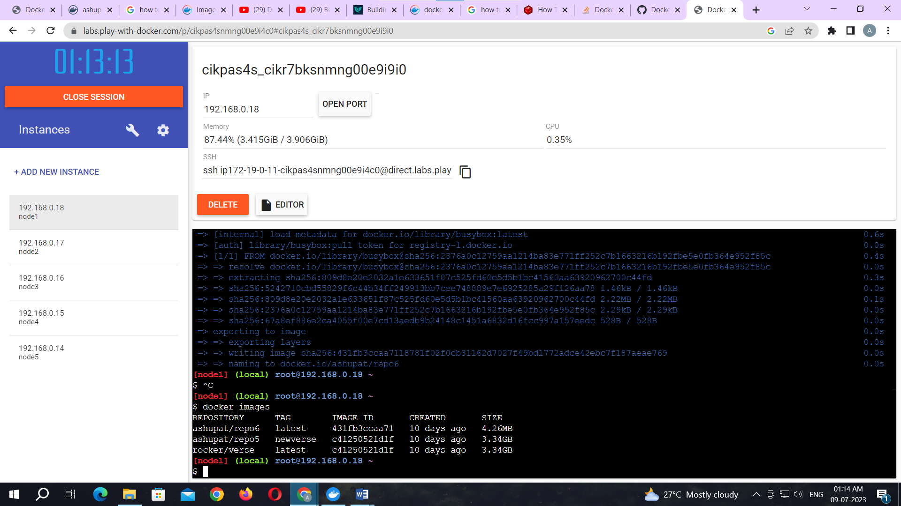

Command: to tag image

docker tag 431fb3ccaa71 ashupat/repo6:image

Command: to push image to docker hub

docker push ashupat/repo6:image

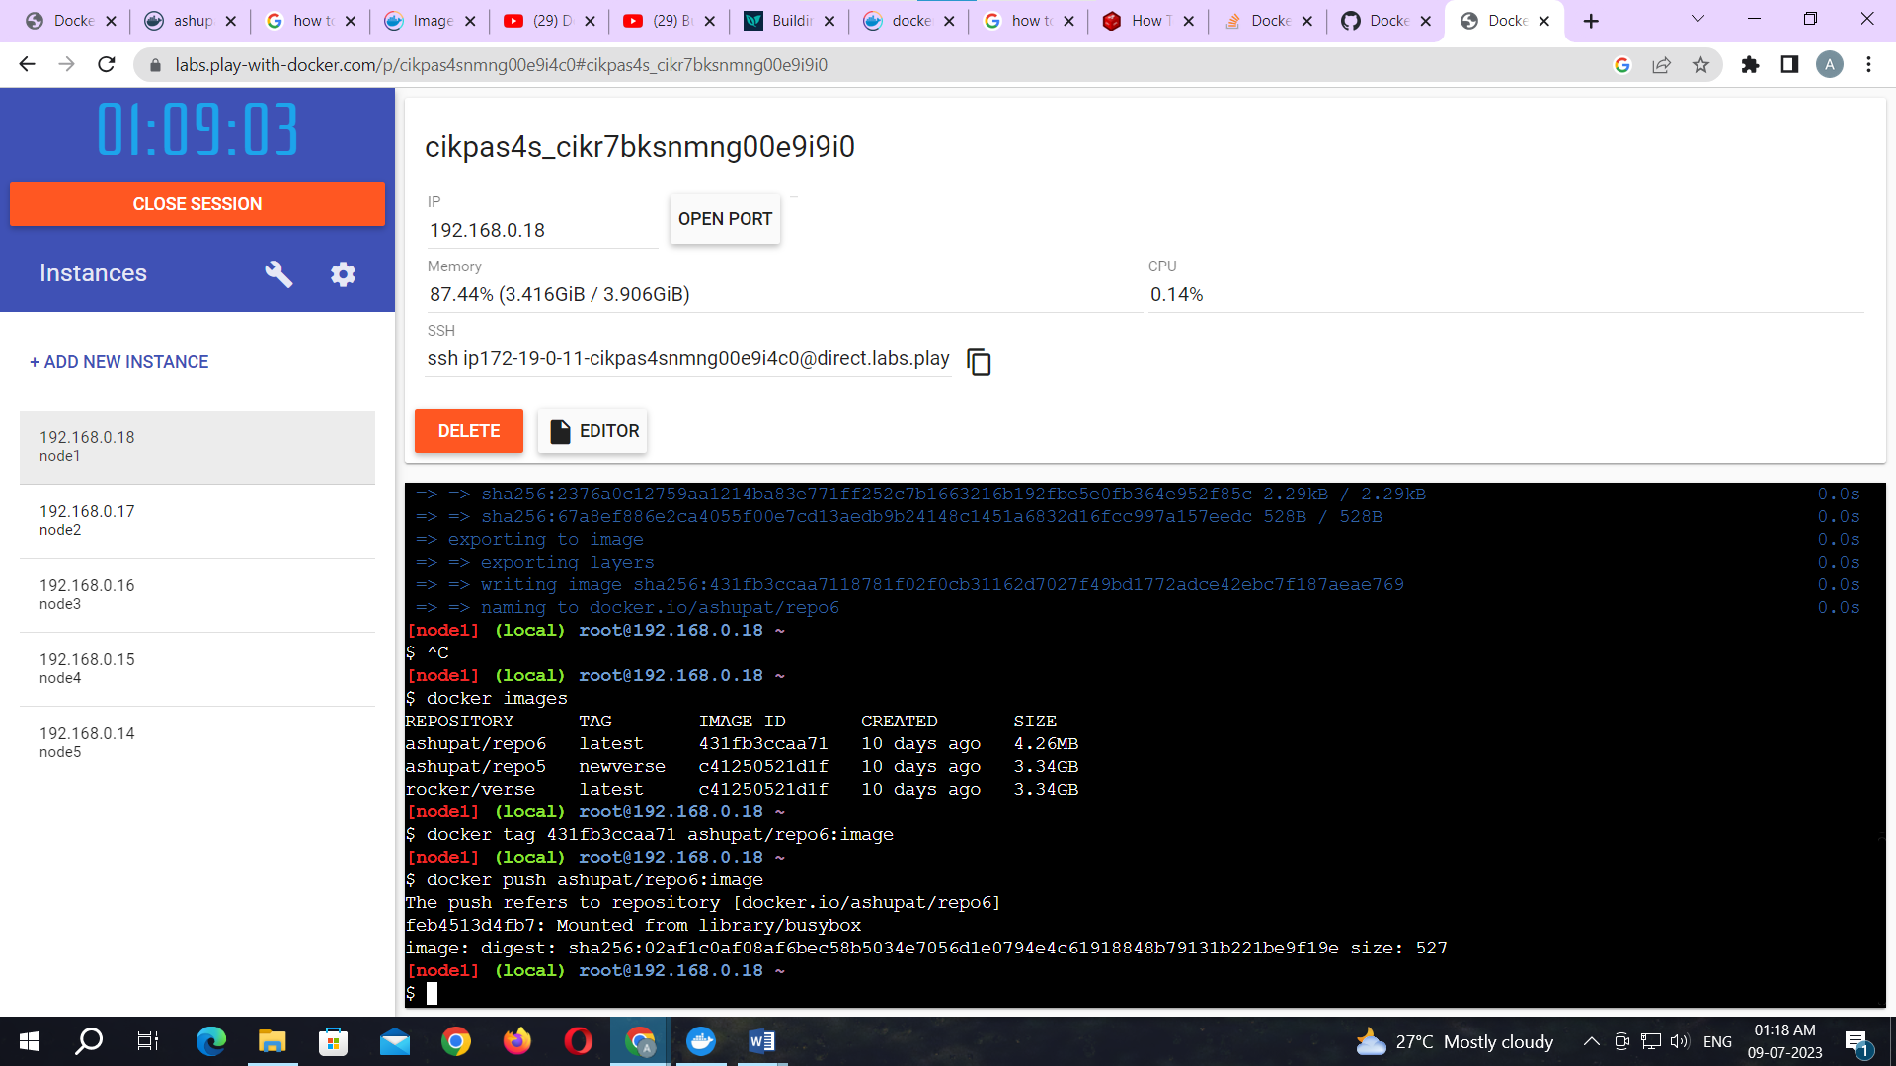

Now check it on docker hub.

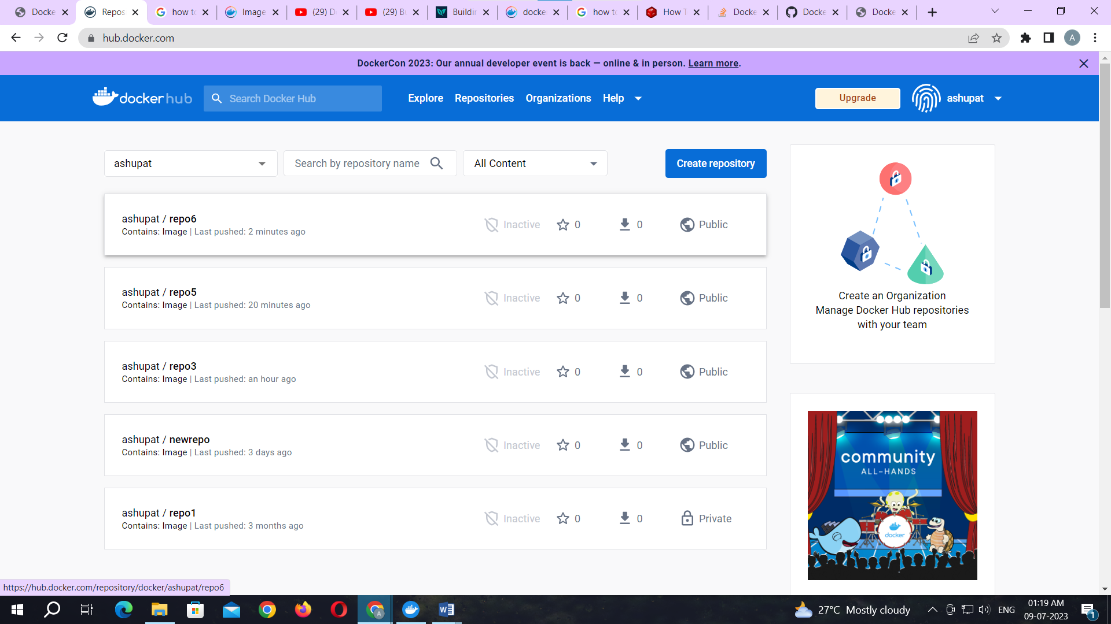

Command: to run docker image:

docker run kbdocker11/repo2

**Output:**

